13.32: a) At the top of the motion, the spring is unstretched and so has no potential
energy, the cat is not moving and so has no kinetic energy, and the gravitational potential
energy relative to the bottom is .
This is the total energy, and is the same total for each part.
- 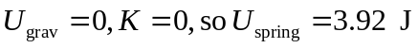.
- At equilibrium the spring is stretched half as much as it was for part (a), and so
.

